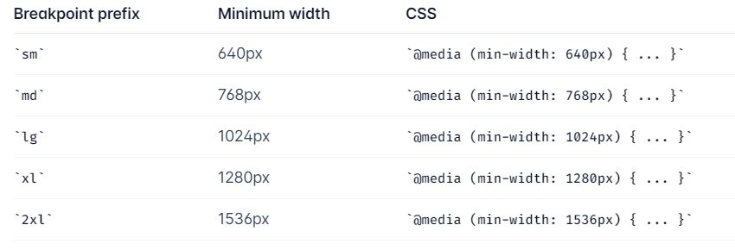

height

width

margin

max-width

min-width

max-content

min-content

fit-content

padding

container

margin auto

position static, relative, absolute, sticky, fixed

z-index

flex

justify-center, flex-start, flex-end, start, end, space-between, space-around, space-evenly

flex-col

flex-row

flex-1

flex-order

items-center

grid

grid-cols-3

grid-rows-3

gap

col-gap

row-gap

font-size

font-style

font-family

font-weight

border

border-radius

border-color

border-size

background

img

i

a